***Cloud Computing Fundamental Concepts***

**Introduction -**

This report will demonstrate an understanding of the fundamentals of Cloud Computing and its architectures. It will also analyse the evolution and fundamental concepts of Cloud Computing.

**1.Brief description of the problem and the fundamental Concepts of cloud computing and the technologies are used (less than 400 words).**

**What is Cloud Computing ?**

Cloud computing involves storing and viewing files and applications over the Internet instead of the hard drive of your machine.

Cloud computing has two aspects to it. More generally, workloads are performed centrally over the Web in the data centre of a private corporation, often known as the "internet cloud" paradigm. Popular public cloud offerings— such as Amazon Web Services (AWS), Salesforce's CRM framework, and Microsoft Azure— all highlight this common notion of cloud computing. Currently, several companies are using a multi-cloud solution.

The second meaning of cloud computing explains how it works: a virtualized resource pool, from raw computing power to device capabilities, available on demand. Once consumers buy cloud services, the vendor reacts to those demands using automated processing rather than manual provisioning.

**What is the importance of Cloud Computing?**

Creating infrastructure that supports cloud computing currently accounts for even more than a third of all IT investments globally, as per IDC report. Elsewhere, investment on conventional, in-house IT continues to fall as processing workloads continue to shift to the cloud, including public cloud infrastructure delivered by providers or private platforms created by companies themselves.

**Cloud computing Benefits -**

The precise advantages can differ depending on the type of cloud service provided, however, basically, utilising cloud services ensures that businesses do not have to buy or manage their own data systems.

The main selling point of the cloud is to reduce the amount of time on the market for applications which need to be interactively scaled. Nevertheless, programmers are gradually attracted into the cloud by the proliferation of innovative new technologies that can be implemented into software, from artificial intelligence to Internet of Things (IoT) networking.

**Types of Cloud Computing Services -**

**SaaS ( Software as a service) -**

A type of public cloud computing uses a client to distribute software over the internet. The most common SaaS business apps can be contained in Google's G Suite and Microsoft's Office 365; Salesforce leads the pack of enterprise applications. However, virtually all enterprise applications, including Oracle and SAP ERP suites, have adopted the SaaS model.

**IaaS ( Infrastructure as a Service) -**

At the basic level, IaaS public cloud providers offer pay-per-use hosting and processing facilities. But the wide range of services provided by all major public cloud providers is astounding: highly scalable repositories, virtual private networks, big data analytics, developer tools, machine learning, device management, and so on.

**PaaS (platform as a service) -**

PaaS provides a set of resources and workflows that specifically target developers who can use common software, processes and APIs to accelerate the development, testing and delivery of apps. Salesforce's Heroku and Force.com are popular PaaS cloud offerings; Pivotal's Cloud Foundry and Red Hat's OpenShift can be deployed on site or accessed through major public clouds.

**FaaS (functions as a service) -**

FaaS, the cloud equivalent of serverless computing, adds another layer of complexity to PaaS so that developers are completely isolated from everything in the stack underneath their application. Instead of using virtual servers, warehouses, and programme runtime, they upload loosely usable blocks of code and schedule them to cause a certain case.

**What is the future of cloud computing?**

Given its long track record, cloud computing is already at a fairly early level of acceptance. Most organisations are still deciding what software to transfer and when. Nonetheless, use is only likely to increase as companies get more happy with the idea that their data is somewhere besides a computer in the basement.

**2. Architectural design (you should include architectural diagram and description).**

This section will be designing an appropriate architectural Cloud Computing framework for a given scenario. It will also demonstrate an understanding of the fundamentals of Cloud Computing and its architectures.

**ComC Current Network Design -**

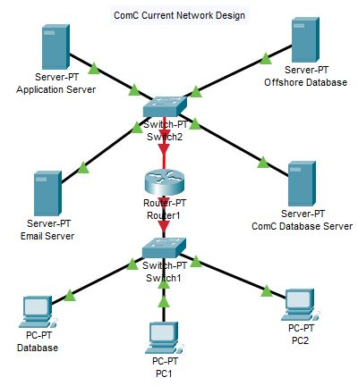

**Description -**

The above model is a current representation of an architectural design for ComC without implementation of the cloud. There are four servers which include the application server, offshore database server, Email server and the ComC database server which are all connected to a switch and protected by the firewall. These servers all then connected the router to be accessed by the end users through a switch.

**ComC Network Design after implementing the Cloud -**

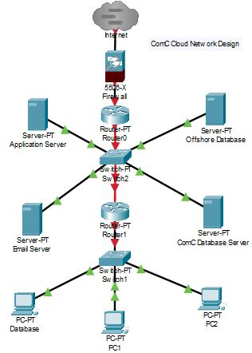

**Description -**

The above model is a representation of an architectural design for ComC which implements the cloud to access data which is protected by a firewall so the data in the cloud is secure from any threats. There are four servers which include the application server, offshore database server, Email server and the ComC database server which are all connected to a switch and protected by the firewall. These servers all then connected the router to be accessed by the end users through a switch.

**3. Proposed solution and discuss why ComC should or should not migrate to Cloud (higher level solution description – around 500-1000 words).**

This section will be discussing the proposed solutions ComC and why they should or should not migrate to the cloud. It will also discuss why an organisation should migrate to a Cloud Computing solution.

**Why ComC should move to the cloud -**

Here are the reasons ComC should migrate to Cloud -

**Price savings -**

The biggest benefit ComC to move to cloud computing is cost savings. This lets them avoid considerable capital costs because they don't need any actual infrastructure expenditure. They also don't need trained personnel to operate the equipment. The procurement and maintenance of hardware is carried out by the cloud service company.

**Strategic advantage -**

Another benefit for ComC is Cloud computing has a competitive edge on the rivals. This lets them use the new software at any time without spending your time and resources on upgrades.

**High Speed -**

If ComC implements Cloud computing it will help them to easily launch the software with less taps. The quicker delivery helps them to get the tools they need for their device within a matter of minutes.

**Back-up and recover data -**

Once ComC’s data is stored in the cloud, it is simpler for them to get back-up to recreate the data, which is otherwise very time-consuming on-site.

**Automatic Application Implementation -**

App implementation is something that happens automatically in the cloud. Therefore, ComC does not need to make additional efforts to design and combine the software as per your requirements.

**Dependability Quality**

Quality of dependability is one of the main advantages of cloud computing. You could always get instant updates on the improvements.

**Other Benefits -**

Many Essential Benefits In addition to the above, some other benefits of cloud computing include: On-Demand Self-Service Multi-Service Offers Resilient Storage Quick and Efficient Virtualisation Provides Low-Cost Computer Offers Improved Online Security Location and User Independence Always accessible, and varies dynamically changed to increase demand allows access to pay-per-use Web-based management and API interfaces.

**Why ComC should not move to the cloud -**

Here are the reasons why ComC should not move to the cloud -

**Output May Vary -**

If you operate in a cloud environment, the code is operating on a platform that offers services to other organisations at the same time. Some selfish action or DDOS assault on your neighbour could have an impact on the performance of your shared resource.

**Technical Problems -**

Cloud technology is always subject to failure and other technical issues. Even the strongest cloud service company firms will encounter this kind of problem despite maintaining high maintenance standards.

**Security Threat in the cloud -**

A further downside when operating in cloud computing providers is security risk. Once you embrace cloud technology, you should be conscious that you will exchange all the sensitive information of your organisation with a third-party cloud computing service provider. Hackers may have access to this information.

**Downtime**

Downtime often needs to be considered when dealing in cloud computing. This is because the cloud provider can face power loss, poor internet connectivity, maintenance of services, etc.

**Connectivity Proper -**

Internet connectivity is a must for cloud computing. Without an internet connexion, you can't access the internet. In fact, there's no other way you would gather data from the web.

**Higher Bandwidth -**

Most cloud storage service providers limit the use of their customers by bandwidth. Therefore, in the case that your company meets the allocation, the additional charges could be extremely expensive.

**Lack of service -**

Cloud Computing organisations tend to provide sufficient customer support. We also want their customers to focus on FAQs or online help, which can be a tiresome task for non-technical people.

**Conclusion:**

For all the pros and cons, we can not argue that cloud computing is the fastest growing aspect of network computing. This offers a great benefit to people of all sizes: easy consumers, entrepreneurs, companies and all forms of organisations. Therefore, this development is here to stay for a long time.

**4. What are the different cloud storages available for ComC in both Windows Azure and AWS. Then choose one you will use for ComC. In your discussion you should include the data and applications mentioned in the above scenario?**

This section will be discussing the different cloud storages available for ComC in both Windows Azure and AWS. It will also discuss the data and applications mentioned in the scenario.

The different cloud storages available for ComC in both Windows Azure and AWS are discussed below -

**AWS and Azure Cloud: Block Storage -**

Block Storage splits the data into pieces of the same dimension. It helps users to change a specific piece of data and do so easily. Blocks are always connected to a cloud server, such as Azure VM or Amazon EC2. They're going to store the OS to set up a virtual machine.

**AWS and Azure software comparison:** Amazon EBS stands for Elastic Block Storage: the default storage device for Amazon EC2. Azure Virtual Disks, which link to Azure Virtual Machines, also use a block storage device. The entire image of the server is contained in a block unit. Cloud block storage comes as a conventional magnetic hard disc drive or as a fast solid state drive (SSD). And the Raid

**Block AWS and Azure Storage Pricing -**

AWS and Azure cloud prices vary across countries, but we'll look at rates for similar parts of the US as an example. Amazon EBS: $.045 per Gb for HDD, SDD $.10 per GB. Prices are going up for higher IOPS. Easy Tier: offer 30 GB of SDD for easy. Azure virtual disc: $.05 per GB of HDD. SSD is $19.71 for 128 GB a month.

**AWS and Azure Cloud: Object Storage -**

Object Cloud Storage is another type of cloud storage for your data to be included in this Azure Blob Storage vs. Azure AWS S3 contrast. In addition, the details are obtained and interpreted from an application. AWS data storage comes in the form of Amazon S3, or Simple Storage Service, while Aws file storage is accessible from Microsoft Blob Storage. Amazon S3 and Azure Blob Storage are massively scalable object storage systems for unstructured data. Storage objects have all the data stored together. You can not alter parts of the object, as opposed to block storage.

Object Cloud Storage helps you to extend your usage to as much data as you need. Not only that, but you can store huge files as well. The biggest Amazon S3 and Azure resources are around 5 Gb. You need to be well coordinated in your programme design before you start moving too aggressively. There are different ways to get your data to AWS. If your data is too wide to be sent from your old data centre

**Object AWS and Azure Storage Pricing -**

Amazon S3: Amazon S3 data costs $0.023 per GB per month through the first 50 Mb, and then the price goes down. Prices are in proportion to network usage. Free Tier: offer 5 GB free of charge. Glacier archive capacity is $0.004 per GB per month. Azure Blob Storage: Azure blob storage begins at $0.0184 per GB for hot storage, then goes down to $0.01 per GB a month for cold storage, and $0.002 for archive storage.

**Cloud Network Attached Storage (NAS) -**

In the past, you had to plan for the future and buy additional resources to predict the storage needs of the company ahead of time, whether it was hard drives, NAS storage, or tape backup systems. You can now easily instal tonnes of data in the cloud without any initial investment or over-provisioning.

Azure has a very easy-to-use service called Azure File Storage. Add a new file sharing from your Azure storage account. Choose link to get the Windows "Web Using" button, as well as the Linux "instal" command for Samba, as Azure File Storage uses the SMB mapping protocol. And your new mount will be available. You can hold an infinite number of files and you're paid for what you're using.

AWS provides similar functionality to Amazon Elastic File System (Amazon EFS). Amazon EFS can be installed on Amazon EC2 servers. Amazon EFS uses NFS V4.0/4.2 for stacking, but is currently only available in four AWS areas. You need a VPN or a Direct Connect connexion to AWS to instal it on-site, because Amazon EFS can't be easily reached.

**AWS and Azure Cloud NAS Pricing -**

Looking at similar US regions again as an example here are how prices compare. It should be noted that both AWS and Azure add fees for access to the data:Amazon EFS: $0.30GB per month. Free tier: gets 5GB on sign-up. Azure File storage: $0.06 per GB per month for locally-redundant storage, though prices increase for more dispersed redundancy options.

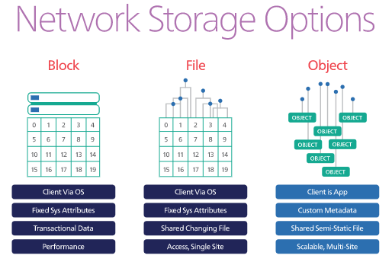

**In Conclusion -**

According to the Scenario a **Block Storage** will be an ideal design for ComC to implement in their database structure as block storage data is structured by file IDs (e.g. sector number) and can be arranged as a database (called a file system) or an application-specific framework. The network operating system has connexions to block storage via the Fibre Channel or iSCSI or via a DASD (directly attached storage device). Block storage is suitable for transactional or organised details such as file systems, repositories, activity records, swap spaces or VMs. Optimized for block-level performance expressed in IOPS (Input / output activity per second).

The sky's the limit of cloud storage, no matter who wins the AWS vs. the Azure clash. Take a few minutes to reflect about your desires, and set them up. Simply change your settings should you change your mind or make a mistake, because you're just paying for what you're using. Startups have long held the image of being agile and quick to grow, while companies were all about moving slowly and taking a lot of time to change. The latest scalability of the cloud makes it possible to change the nature of this understanding.

**5. Detailed design:**

1. **Deployment of the cloud model (description of the model, and discussion on why that model should be chosen for ComC supported by a diagram).**
2. **Compare the Service models and discussion on why that model/s will be adequate for ComC.**
3. **This section will be designing a cloud model and why it would be chosen for ComC with a diagram. It will also compare the service models and discuss why that model will be adequate for ComC.**

**What is a cloud Deployment model ?**

A cloud deployment model describes four technology architecture models: public cloud, private cloud, group cloud, and hybrid cloud. The cloud architecture model is characterised by where the computing infrastructure sits and who has power over that infrastructure. Deciding which architecture model you're going to use is one of the most critical cloud implementation decisions you'll make.

**Migrating to the Cloud**

Application delivery models show how cloud services are made available to consumers. The four cloud-related application templates are as follows:

**Public Cloud -**

Public cloud As the name suggests, this style of cloud delivery model serves those customers who want to use a computing tool, such as hardware (OS, CPU, power, storage) or software (application server, database) on a subscription basis. The most common uses of public clouds are for device development and testing, non-mission-critical activities such as file sharing, and e-mail. The most common uses of public clouds are for device development and testing, non-mission-critical activities such as file sharing, and e-mail.

**Private Cloud -**

Private cloud computing is usually used by a single organisation. Such a network may be operated by the company itself to support different user groups, or may be handled by a service provider who takes care of it either on-site or off-site. Commercial clouds are more costly than public clouds because of the capital expenditure required in the creation and management of clouds. Private clouds are, however, best able to address the security and privacy issues of companies today.

**Hybrid Cloud -**

A hybrid cloud, an enterprise utilises combined private and public cloud services. Most companies use this approach when they need to quickly update their IT systems, such as using public services to support the resources provided within a private cloud. For example, if an online retailer requires additional computing resources to manage its Web applications during the holiday season, it can access such resources via public clouds.

**Community Cloud -**

Its implementation paradigm involves multiple organisations exchanging community-based computing resources; exceptions involve colleges collaborating in certain areas of research, or police departments within a county or state sharing of computing resources. Connection to a shared cloud environment is usually limited to community members.

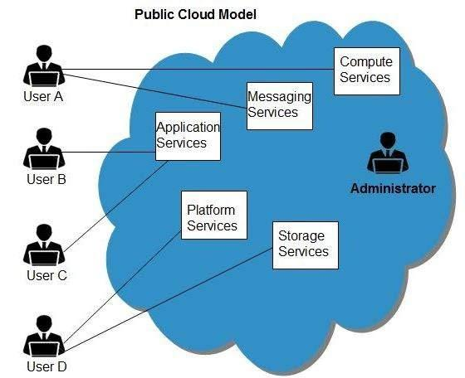

**Choosing the perfect deployment model for ComC -**

The best deployment of the cloud model that is chosen for ComC is the public model as for the following reasons below -

**Public Cloud Model -**

**User Experience**

The public cloud offers a variety of user experiences based on which delivery model they have selected. Public cloud, you may not have influence over the user experience in some situations. In a shared cloud environment, the influence over user experience relies on the arrangement you have with other members of the community.

**Security -**

Safety is always a complicated issue. It's even more difficult when it comes to dealing with the internet. It's mainly a matter of faith. Who do you trust with your safety? Most companies may prefer to trust a third party rather than trust themselves. There's absolutely nothing wrong with that. Safety is such an important concern that you need to do what you believe.

**Responsibilities -**

Obligations vary considerably based on which cloud platform you plan to use. This could be another key factor in your judgement. In reality, one of the main drivers of public clouds is the willingness of companies to reduce their internal obligations.

1. **This section will compare the Service models and discussion on why that model/s will be adequate for ComC.**

There are three types of Cloud Service Models they are Saas, IaaS, PaaS -

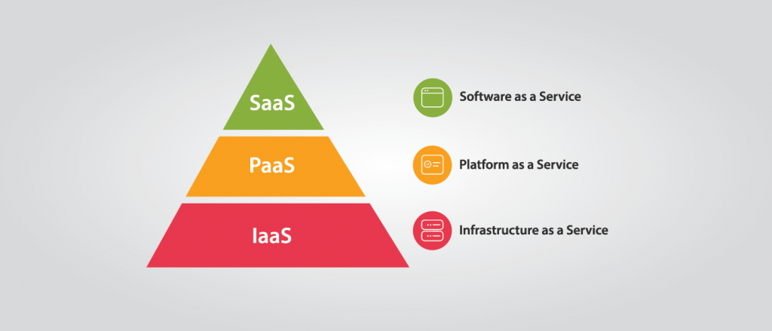

**SaaS -**

SaaS or Software as a Service is a platform that offers quick access to cloud-based web apps. The company controls the entire software system that you can use using a web browser. All programmes operate on the web, and you can use them with a paid registered membership or with limited access free of charge. SaaS does not include any modifications or updates from your current software network. It removes the need to instal software on each of the machines with maintenance and support from the manufacturer. Many known examples of SaaS include Google G Suite, Microsoft Office 365, Dropbox, etc.

**Benefits**

**Affordably priced –**

SaaS is inexpensive as it reduces the costs involved in the acquisition, deployment, repair and upgrading of computer hardware.

Anywhere Accessibility–With SaaS, you can access services from anywhere using any device, such as smartphones, that removes the constraints of on-site apps.

**Anywhere Accessibility –**

SaaS enables you to access services from anywhere using any computer, such as smartphones, that removes the constraints of on-site apps.

**Ready to use –**

You can quickly set up SaaS services to make them usable in no time. All it takes is for you to sign up for a service that gives you access to fast and powerful computing resources.

**IaaS -**

IaaS or Infrastructure as a Service is essentially a computer deployment of cloud computing tools. The IaaS cloud provider can provide you with a wide range of computing infrastructures, such as storage, servers, networking hardware, maintenance and support. Businesses should opt for the computation of the services needed without the need to build equipment on their premises. Amazon Web Services, Microsoft Azure, and Google Compute Engine are three of the major suppliers of IaaS cloud services.

**Benefits -**

**Minimize Costs –**

Deploying an IaaS software platform reduces the need for on-site equipment to reduce costs.

**Increased Scalability –**

As the most modular cloud computing platform, IaaS helps you to scale computing resources up or down on request.

**Fast Deployment –**

IaaS allows you to easily deploy servers, operation, inventory, and network to get it up and running in no time.

**PaaS -**

Platform as a Service or PaaS is basically a cloud platform where you can create, check and manage various applications for your enterprise. Implementing PaaS simplifies the creation of enterprise software. The simulated runtime environment created by PaaS offers a suitable room for developing and testing software. All services available in the form of computers, storage and networking can be handled either by the client or by the vendor of the site. Google App Engine and AWS Elastic Beanstalk are two common PaaS instances. PaaS is also a subscription based service that gives you different pricing options depending on your business requirements.

**Benefits -**

**Minimal Design Time –**

PaaS eliminates development time by supplying certain computing resources, such as server-side modules, to simplify the process and increase the attention of the development team.

**Various Programming Language Support –**

PaaS provides support for various programming languages that software development firms can use to build applications for different projects.

**Improved Communication –**

Through PaaS, the company will benefit from improved communication that will help integrate the staff in different locations.

**Choosing the perfect Service model for ComC-**

The best service model that is chosen for ComC is the SaaS service model as for the following reasons below -

**SaaS is the perfect solution for the Service model for ComC -**

**Affordably priced –**

SaaS is inexpensive as it reduces the costs involved in the acquisition, deployment, repair and upgrading of computer hardware.

Anywhere Accessibility–With SaaS, you can access services from anywhere using any device, such as smartphones, that removes the constraints of on-site apps.

**Anywhere Accessibility –**

SaaS enables you to access services from anywhere using any computer, such as smartphones, that removes the constraints of on-site apps.

**Ready to use –**

You can quickly set up SaaS services to make them usable in no time. All it takes is for you to sign up for a service that gives you access to fast and powerful computing resources.

**6. a. It is said, “Cloud Computing can save money”. What is your view regarding ComC moving to Cloud**

This section will be reviewing ComC moving to the cloud as “Cloud Computing saves money” and will cover the reasons for moving to the cloud.

If ComC decides to move into cloud computing in an effort to save money then these would be the benefits that would boost the productivity for ComC future business.

As the mainstream use of cloud computing is still relatively new, several businesses remain apprehensive about introducing cloud solutions. To businesses with existing IT departments and facilities, converting to a cloud system may seem impractical and inconvenient. Nevertheless, the cloud can offer significant financial benefits, such as budget savings and increased productivity at the workplace. In reality, a new Rackspace report surveyed 1,300 businesses and found that 88 per cent of cloud customers had cost savings and 56 per cent had an increase in profits. Here are a few great ways cloud computing can save capital.

**Hardware -**

Cloud computing has the downside of rising hardware costs. Instead of ComC having in-house machinery, the technology demands are transferred to the manufacturer. New hardware may be massive, costly, and awkward for fast-growing companies. Cloud computing is alleviating these problems as information can be accessed quickly and easily. Even better, the cost of repairing or replacing equipment is passed to the vendors.

In addition to manufacturing savings, off-site equipment lowers internal power costs and saves space. Large data centres can take up valuable office space and produce a large amount of heat. Switch to cloud services or storage can help maximise capacity and significantly reduce energy costs.

**Capital Investment -**

Cloud systems are typically available in a compensation-as-you-go pricing model. This style offers value and versatility in a number of ways. For the most part, ComC’s business doesn't have to pay for equipment that isn't being used. Cloud computing typically only pays per account, as opposed to an upfront licence.

By fact, pay-as-you-go services can be cancelled at any point that eliminates the financial risk of any programme that does not function. Eventually, the up-front expense of the cloud is smaller than that of in-house systems. Cloud systems offer great versatility for businesses that need top-tier goods but do not have substantial funds available instantly.

**Productivity -**

In addition to maximum labour efficiency, cloud computing can be extremely cost-effective for companies due to increased labour productivity. In fact, the implementation of cloud software is quicker than traditional installation. Cloud software delivery may take place in a matter of hours instead of weeks or months that a typical company-wide implementation can require. It ensures the workers will spend less time sitting and more time working. Adoption period is also for cloud solutions. SaaS programmes are usually available through a web browser and can be accessed quickly and easily.

Eventually, most cloud computing and mobile services are accessible everywhere, via an internet connexion. This is great news for companies that rely on travel or telecommunications policies in place.

**Labor/Maintenance -**

Cloud systems can also contribute to a dramatic reduction in labour and maintenance costs. As a result of equipment being operated by suppliers and held in off-site facilities, there is less competition for on-site IT workers. When servers or other equipment need maintenance or improvements, it is the duty of the manufacturer and does not cost the business any time or money.

Eliminating routine maintenance will allow the IT workers to concentrate on critical projects and innovations. In some situations, this could even involve a reduction in the size of the workforce. In businesses who lack the resources for in-house IT workers, the cloud can help eliminate expensive third party equipment repair bills.

**7. Critical discussion on data migration and the risk involved by exploring**

1. **common problems that are often addressed**
2. **the factors that are too often lead to failure and the tools chosen to realise a cloud computing solution**
3. **the planning and strategy steps to ensure a smooth migration process ( around 1500 words).**

This section will be critically discussing data migration and the risk involved by exploring common problems that are often addressed and the factors that are too often lead to failure and the toolschoosen to realise a cloud computing solution and the planning and strategy steps to ensure a smooth migration process.

1. This section will discuss on the data migration and the risk involved by exploring common problems that are often addressed

Here are a few common problems that are often caused in data migration and risk that are involved in it -

**1. Poor Knowledge of Source Data**

This knowledge gap involves not being aware of the problems that occur in your records, such as duplicates, missing information, misspellings and inaccurate data. It can be too tempting to be complacent and believe that your data will simply be transformed into the specifications of a new system, but fact may imply significant shortcomings when it comes to consumer acceptance.

**2. Underestimating Data Analysis -**

Due to computer system limitations, details may be lost in obscure locations, as there are often no clear fields to contain all data items, or users may not be informed of the function of the usable fields. This will result in missing, erroneous and obsolete knowledge being transmitted through relocation, which is often found quite late in the day, even after the process has been completed.

**3. Lack of Integrated Processes-**

Data transfer typically involves a diverse set of people utilising different technology. The classic example is the use of spreadsheets to record data parameters, which are vulnerable to human error and can not be readily interpreted while analysing data or executing data transformations.

**4. Inability to Validate a Specification -**

Validating the data transition requirements early on with actual data, rather than just recorded expectations, will increase confidence in the implementation of the rest of the measures. While you may well have an overview of your source data, this will not necessarily result in a good specification for transferring and changing data to the target system.

**5. Failure to Validate the Implementation -**

Checking the conversion with full-volume data from the real world helps to cover a broader range of possibilities and checks for the worst-case scenario that could be overlooked when using more simplistic data samples.

1. **the factors that are too often lead to failure and the tools chosen to realise a cloud computing solution**

Here are the reasons that data migration tools that leads to failure -

**1. Poorly understood / undocumented legacy systems:**

The data environment of each organisation is special. It can include everything from decades old mainframes to home-grown one-off applications, each with its own level of support. Documentation may be non-existent, operational expertise may be minimal, and key staff may be approaching retirement.

**2. Incorrect / incomplete specifications that do not reflect reality:**

Data migration criteria are often based on assumptions regarding evidence rather than actual facts. Mappings and adaptations based on assumptions may be missing key values.

**3. Low Information Quality / Incomplete Data:**

The new system is just as valuable as the information underpinning it. Lost, unreliable or incompatible legacy data that create ripple effects when it comes to the new system. Although data may never be 100% safe, lack of attention to data quality will cripple even the most focused forward programmes, contributing to last-minute clean-up efforts.

**4. Lack of attention to detail:**

It is very easy to ignore seemingly innocuous differences between source and goal programmes. Fields with the same name may mean different things, both within and across frameworks. A different field name may be used through structures for the same reason, or several meanings may have the same underlying meaning.

**5. Constant Changes:**

Data migration programmes are all about transition. Even the most thought-out market expectations start to change until implementation is ongoing and the company learns how the new system works. Improvements will potentially amount in hundreds and need to be implemented and immediately checked to avoid putting the timetable at risk by extending the test cycles.

1. **the planning and strategy steps to ensure a smooth migration process**

Here are a few steps for planning a strategy to ensure smooth migration process which are -

**1. Make sure you understand the advantages and potential risks of a cloud-based system.**

The greatest transformations happen while the eyes are wide open. Shifting your company to the cloud has so many upsides: increased connectivity, scalability, adaptability, incorporation into the software you use... the list is endless. But you also need to be alert for the risks inherent in your online system.

**2. Remember growing cloud storage system is best for your enterprise**

The Big Three Data Storage— Microsoft Azure, Google Cloud, and Amazon's AWS — are all strong choices. The portal is shielded by TLS encryption, which ensures that your network as a whole (though not your own data) will be encrypted by the best in the business.

**3. Consult a cloud security expert -**

The cloud provider you choose will have professional staff on hand to support you during and after migration. To improve these programmes, resolve roadblocks, or enforce data-centric security, enter Virtru.

**8. Summary**

This report will demonstrate an understanding of the fundamentals of Cloud Computing and its architectures. It will also analyse the evolution and fundamental concepts of Cloud Computing. It contains the designing of an appropriate architectural Cloud Computing framework for a given scenario. It will also demonstrate an understanding of the fundamentals of Cloud Computing and its architectures. It discusses the proposed solutions ComC and why they should or should not migrate to the cloud. It will also discuss why an organisation should migrate to a Cloud Computing solution. It discusses the different cloud storages available for ComC in both Windows Azure and AWS. It will also discuss the data and applications mentioned in the scenario. Designing a cloud model and why it would be chosen for ComC with a diagram. It will also compare the service models and discuss why that model will be adequate for ComC. Comparing the Service models and discussion on why that model/s will be adequate for ComC. Reviewing ComC moving to the cloud as “Cloud Computing saves money” and will cover the reasons for moving to the cloud. If ComC decides to move into cloud computing in an effort to save money then these would be the benefits that would boost the productivity for ComC future business. Critically discussing data migration and the risk involved by exploring common problems that are often addressed and the factors that are too often lead to failure and the toolschoosen to realise a cloud computing solution and the planning and strategy steps to ensure a smooth migration process. The reasons that data migration tools lead to failure. steps for planning a strategy to ensure smooth migration process

**Conclusion -**

In conclusion, this report demonstrates an understanding of the fundamentals of Cloud Computing and its architectures. It also analyses the evolution and fundamental concepts of Cloud Computing.

Knorr, E. (2020). *What is cloud computing? Everything you need to know now*. [online] InfoWorld. Available at: https://www.infoworld.com/article/2683784/what-is-cloud-computing.html [Accessed 13 Feb. 2020].

Ranger, S. (2020). *What is cloud computing? Everything you need to know about the cloud, explained | ZDNet*. [online] ZDNet. Available at: https://www.zdnet.com/article/what-is-cloud-computing-everything-you-need-to-know-from-public-and-private-cloud-to-software-as-a/ [Accessed 13 Feb. 2020].

Guru99.com. (2020). *Advantages and Disadvantages Of Cloud Computing*. [online] Available at: https://www.guru99.com/advantages-disadvantages-cloud-computing.html [Accessed 14 Feb. 2020].

Kovacs, G. (2020). *Comparing AWS and Azure Storage Pricing and Features*. [online] Cloud.netapp.com. Available at: https://cloud.netapp.com/blog/aws-vs-azure-cloud-storage-comparison [Accessed 14 Feb. 2020].